

|  |  |  |  |  |  |  |  |  |
| --- | --- | --- | --- | --- | --- | --- | --- | --- |
|  | | | | | | | | |
|  | | DATA ANALYSIS AND VISUALISATION | | | | |  | |
|  |  | | | | | | |  |
|  | | | |  |  | | | |
|  | | | | TIYA MEHTA |  | | | |
|  | | | | BSC (HONS) COMPUTER SCIENCE(SEMESTER 3RD)—TELCO COMPANY CHURNS—MS RAJNI |  | | | |
|  | | |  | | |  | | |

TOOK A DATASET OF TELCO COMPANY CHURNS FROM KAGGLE ….

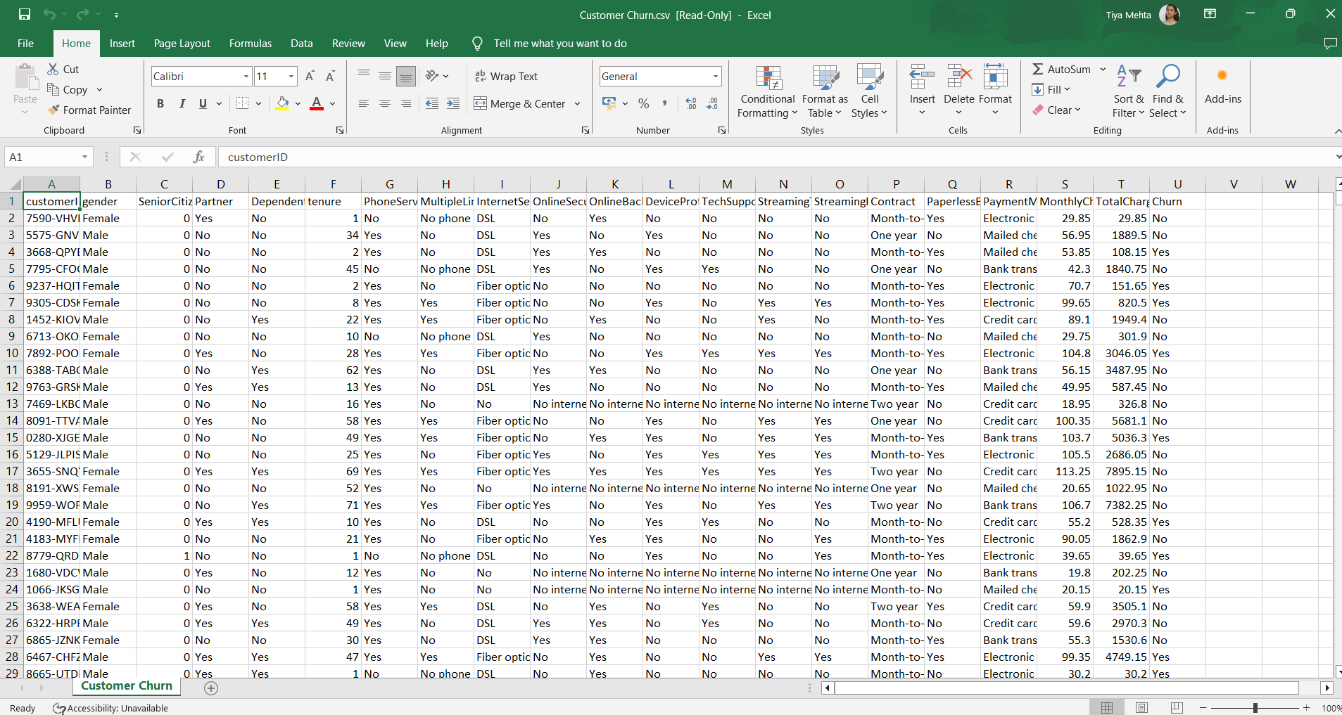

Objective: The analysis explores customer churn patterns, focusing on various factors such as payment methods, contract types, tenure, and demographic attributes. The goal is to identify which factors are most strongly associated with higher churn rates to guide customer retention strategies.

Using the dataset and getting the required dataset displayed for further work…

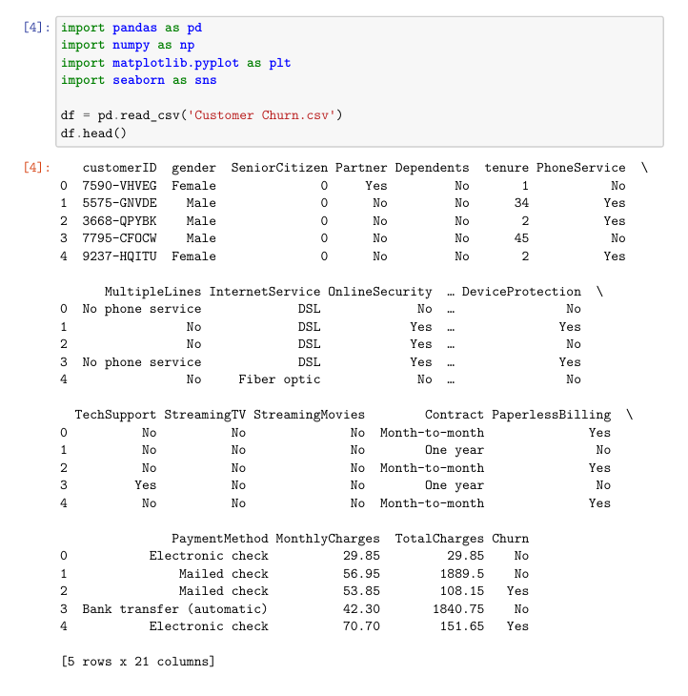

Display information of the dataset ..

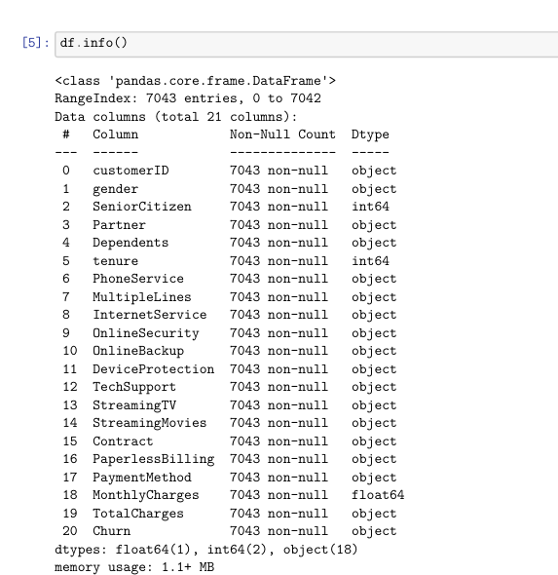

Displaying the coloumn values..

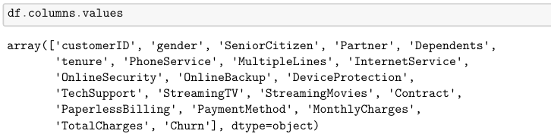

Replacing blanks with 0 as tenure is 0 and no total charges are recorded and change the datatype of total charges to float..

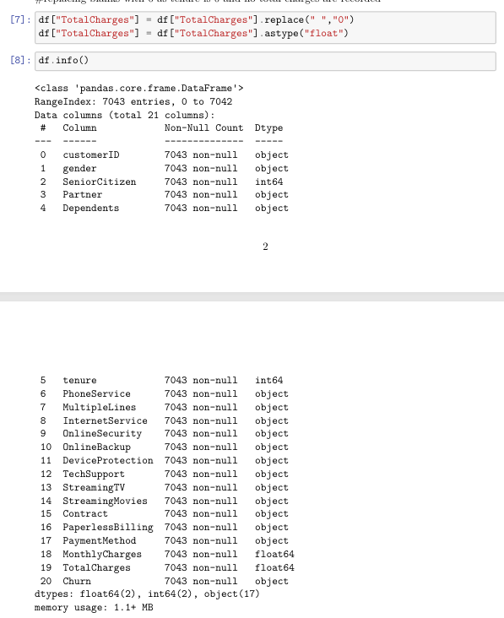

Check number of null values..

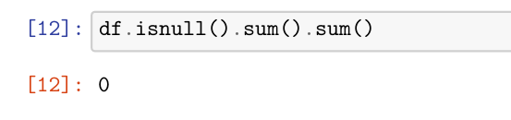

Describing the dataset..

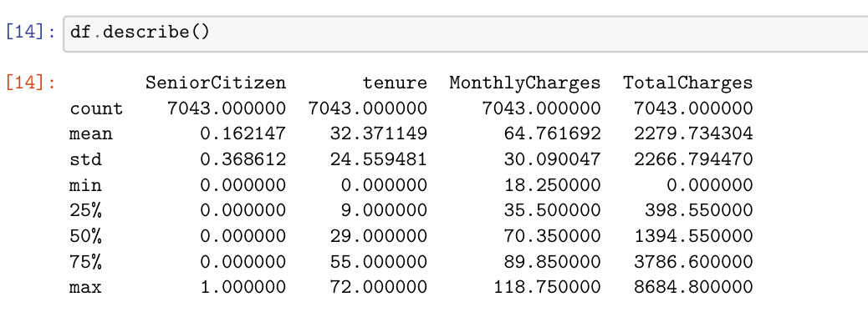

Check for duplicate values..

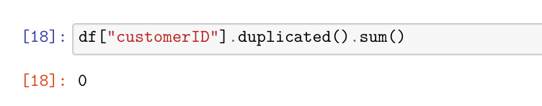

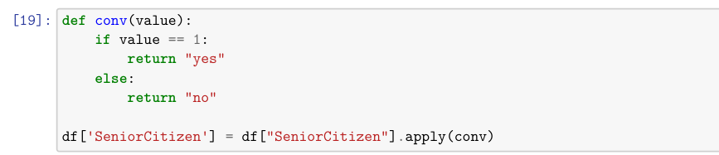

Yes

No

Yes

Yes No



Converted 0 and 1 values of senior citizen to yes/no to make it easier to understand…

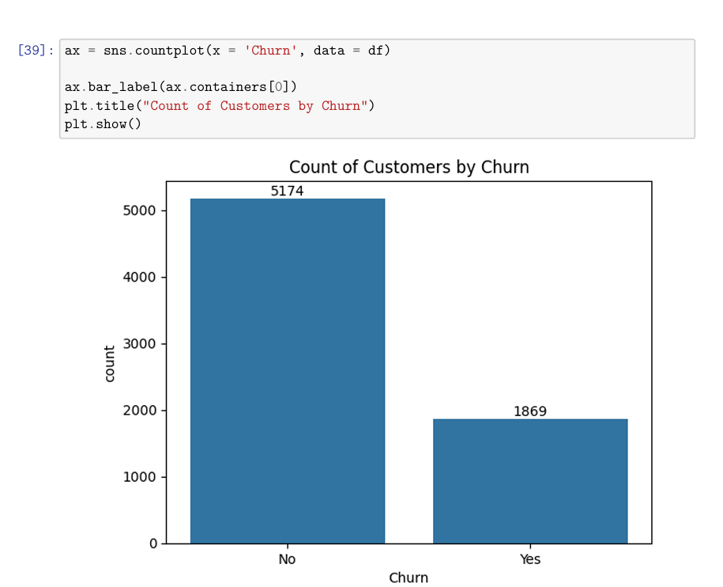

Plotting for showing Number of costumers by churn..

Plotting for showing percentage of churned costumers..

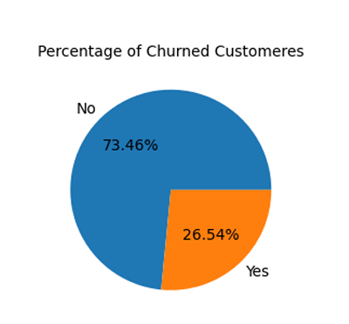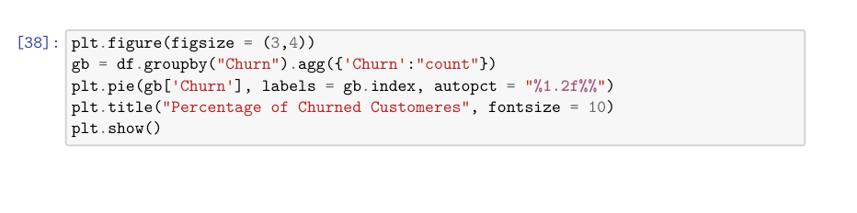

#from the given pie chart we can conclude that 26.54% of our customers have churned out.

Plotting for showing costumers churned by Gender..

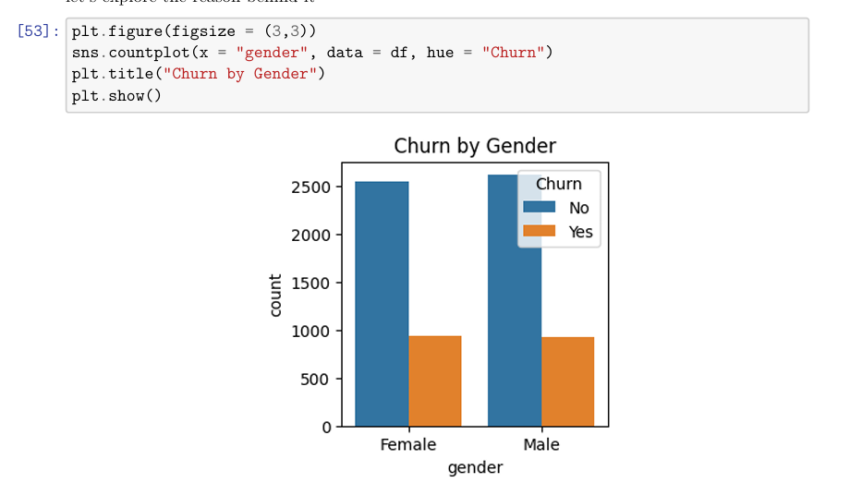

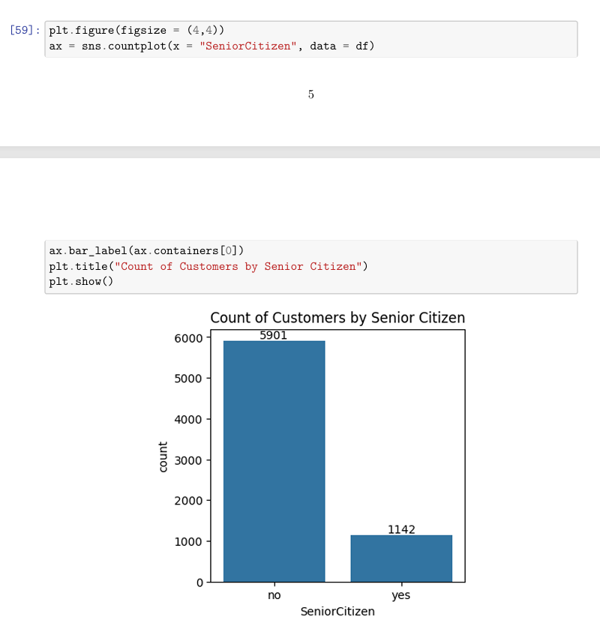

Plotting for showing count of costumers by Senior Citizen..



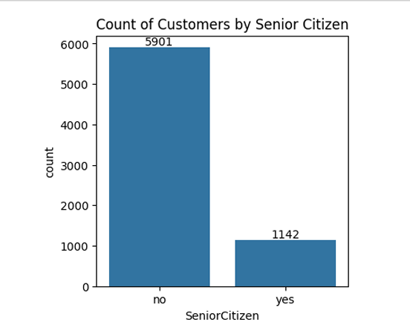

Plotting a stacked graph to show the churned senior citizens

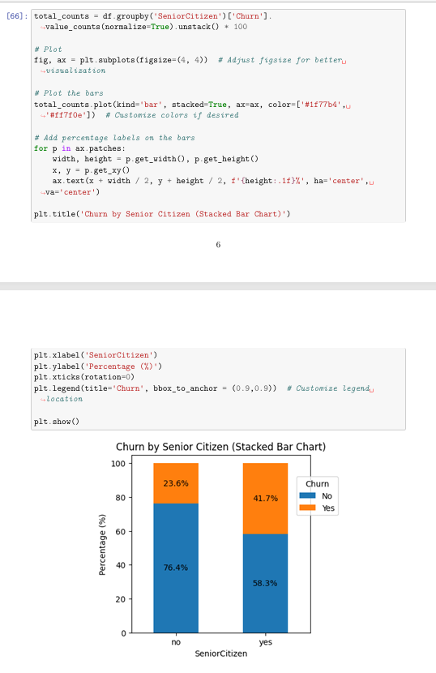

comparative a greater pecentage of people in senior citizen category have churned

People who have used services for a long time have stayed and people who have used services for 1 or 2 months have churned…

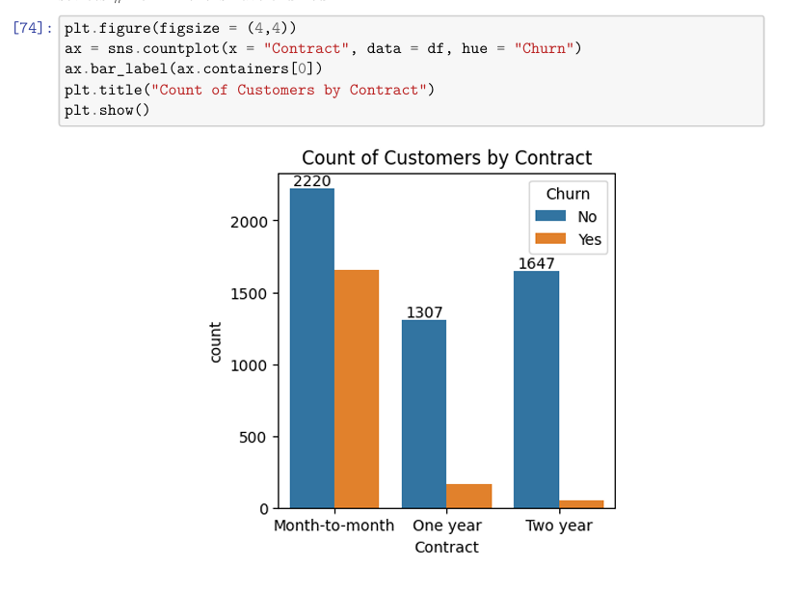

Plotting a chart to show various fields ..

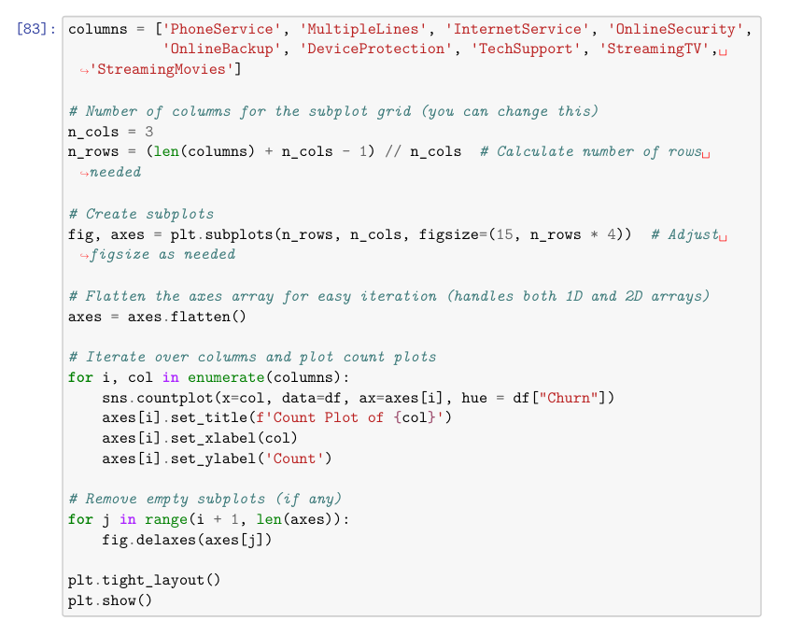

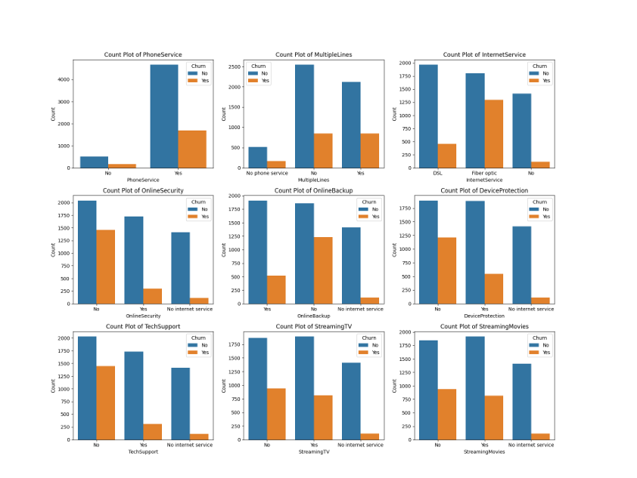#The majority of customers who do not churn tend to have services like PhoneService, Internet Service (particularly DSL), and OnlineSecurity enabled. For services like OnlineBackup, TechSupport, and StreamingTV, churn rates are noticeably higher when these services are not used or are unavailable.

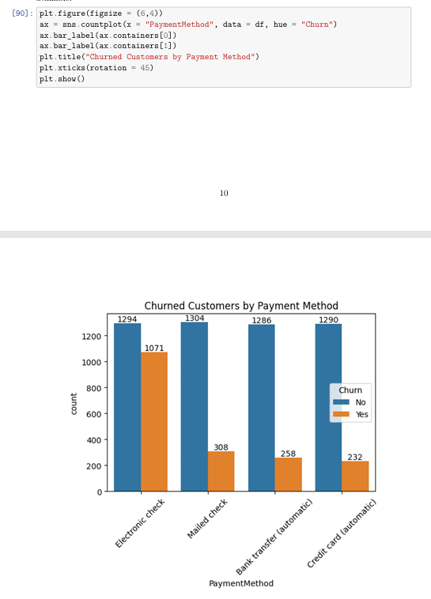

Plot to show churned costumers by Payment method..

**Key Insights & Findings:**

